**Groundwater Hydraulics Final Report**



**Prof. Monica Riva & Prof. Emanuela Bianchi Janetti**

**Harsh**

**Omima Musa Mohmed Abusil**

**Najmeh Koularzadeh**

**Emma Krampe**

**Nabil Rafka**

**Ghodrat Rezaei**

**Table of Contents**

**Part 1 Flow Modeling** **3**

Introduction 3

Selby Location and Geology 3

Well Characteristics 4

Analysis Of Pumping Test Data 5

Numerical Groundwater Flow Model 7

Model Calibration 9

Particle Tracking 13

**Part 2 Transport** **15**

Analysis of transport processes in laboratory column experiments (fixed step injection) 15

Analysis of transport processes in laboratory column experiments (slug injection) 16

Analytical solution 17

1- Sodium-Naphthionate 17

2- Eosine 17

3- Uranine 18

Temporal Moment Analysis Method 19

Chemical reactions typical in groundwater: sorption in natural soils 20

Sorption Mechanisms 22

1- Freundlich Model 22

2- Langmuir Model 23

**Part 3 Geostatistics** **26**

Variogram Models’ Estimation: 26

Kriging Interpolation Method 26

Sequential Gaussian Simulation 33

# Part 1 Flow Modeling

## Introduction

A modelling and calibration exercise of the groundwater abstraction from the Triassic Sherwood Sandstone aquifer in the Shelby area located in Yorkshire, UK was performed. The Triassic Sandstone aquifer contributes to about 26% of the total groundwater in the UK. To its north, the shelby area has the suburbs of York, is bordered by river Aire in the south, and is about 150 km away from the ocean to its east. The abstraction of groundwater from the boreholes in the Shelby area has taken place for over a century. It is the region with the highest depletion of water resources for industrial activity. The objective of the modelling and calibration is to check for the increase in salinity in the wells and the sources of the salinity in this area. The intrusion of saline water in groundwater is one of the prominent causes of degradation of the quality of groundwater. Incursion of marine waters is a common reason for increase in salinity in coastal aquifers. The severe increase in salinity has led to abandonment of quite a few wells and hence it is important to study them. A geochemical and isotropic analysis of the area will be conducted to identify the source of saline water incursion. The modelling will be done over an area of 31.5 x 26 km. The hydrogeology of this area is similar to many aquifers in northern Europe. A steady state flow model of the area will be constructed and calibration will be done by using the information from the observation wells to determine the encompassing flow directions and change in hydrographics. The results obtained will be used for analysing the particle tracking to enhance the understanding of the pattern defined of the saline contamination, which in turn will enlighten us to why only specific wells were contaminated. This report is a stepwise presentation of the modeling of flow and transport in the Selby aquifer to determine the source of saline groundwater.

## Selby Location and Geology

The Selby aquifer covers an area of 31.5 x 26 km and the rivers Aire and Ouse are located in the south of the area. Figure 1 shows the majority of the Triassic Sherwood Sandstone is covered by Quaternary deposits (‘drift’) except for a small sandstone outcrop area at Brayton Braff which is on high ground. Recharge to the aquifer takes place by infiltration through Brayton Braff or by the leakage from the Aire and Ouse rivers. Lithology of the drifts show a mixture of clay and silt which have low hydraulic conductivity. In the north and west side of the area, soil is composed of sand and gravel which provide more permeability and are a recharge pathway to the aquifer. On the east side, the Sherwood Sandstone is overlain by Mercia Mudstone and underlain by Permian Marls and Permian Magnesian Limestone. The area consists of A (Unconfined Aquifer), B ( Confined Aquifer by silt and clay) and C ( Confined Aquifer by Glacial Moraines) as shown in Figure 2.

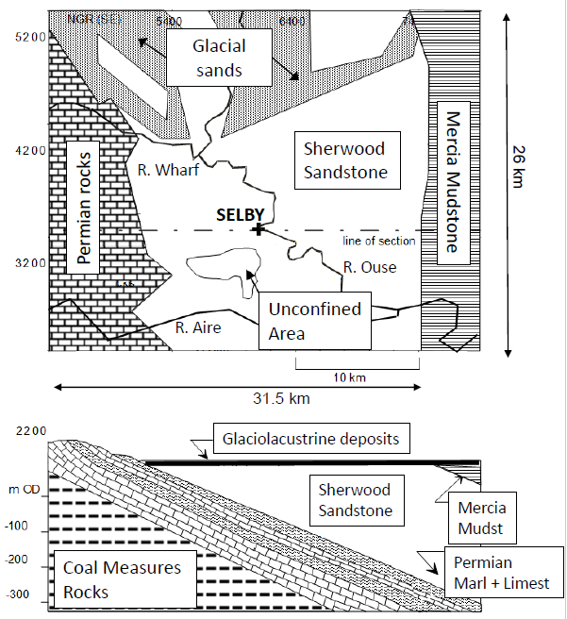

*Figure 1. Geology of the Selby area*

## Well Characteristics

The Selby wellfield is the region with the highest depletion of water resources for industrial activities. In order to carry on the pumping tests, Kelfield, Skipwith, Wooden Farm pumping wells were selected shown in Figure 2. Due to economic reasons, drawdowns are measured in the pumping wells rather than the observation tests, a common field practice. Table 1 shows the well characteristics data conducted in 1985 & 1995.

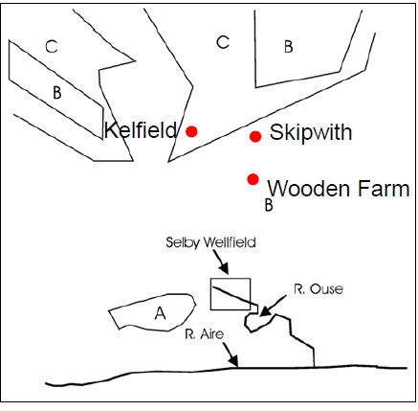

*Figure 2. Pumping well positions and aquifer classification.*

Table 1. Well Characteristics

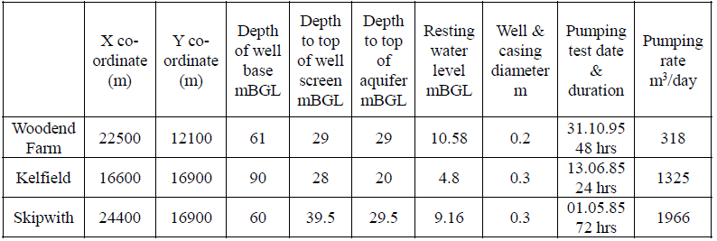

## 

## Analysis Of Pumping Test Data

Using the pumping test data, the transmissivity and storativity of each pumping well was estimated by AQTESOLVER software based on the Theis solution. In order to satisfy the Theis assumption of constant flow rates, the flow rate of the Kelfield pumping well was considered from the time that it became constant (10:15 at 1/06/1985). A plot was obtained for each pumping well as shown below (Figures 3a, 3b, 3c, 3d).

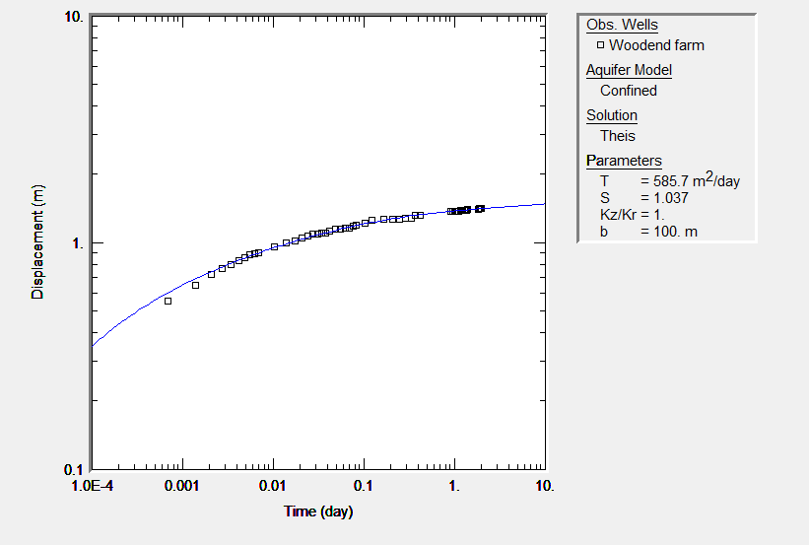

*Figure 3a. Woodend farm well.*

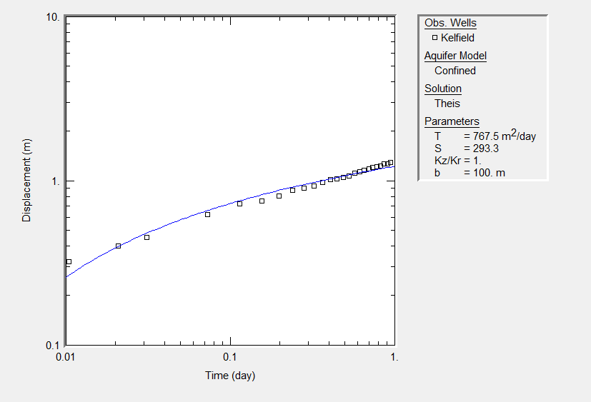

*Figure 3b. Woodend farm well. The curve is achieved by considering the timing after Q became constant.*

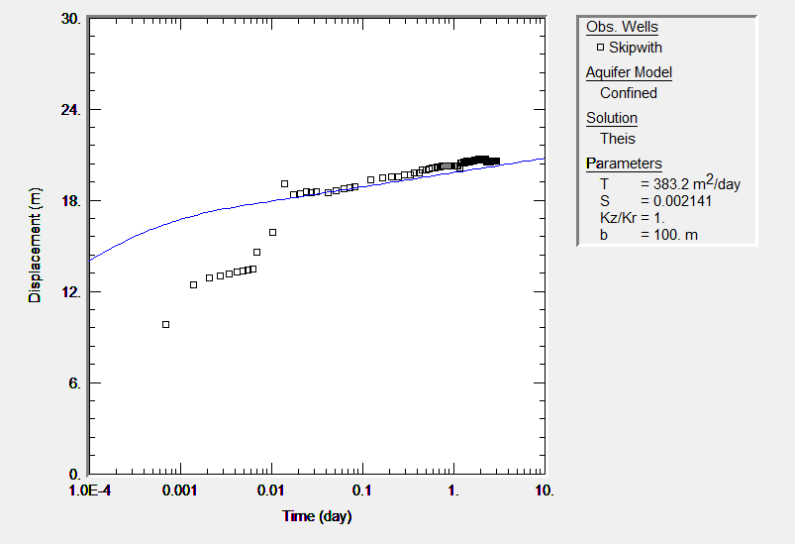

*Figure 3c. Skipwith well.*

The Skipwith well shows a break in the curve (Figure 3c) due to lack of data or discontinuation of the discharge. The estimation was corrected by defining a time period from 0.02 to 10 days (Figure 3d).

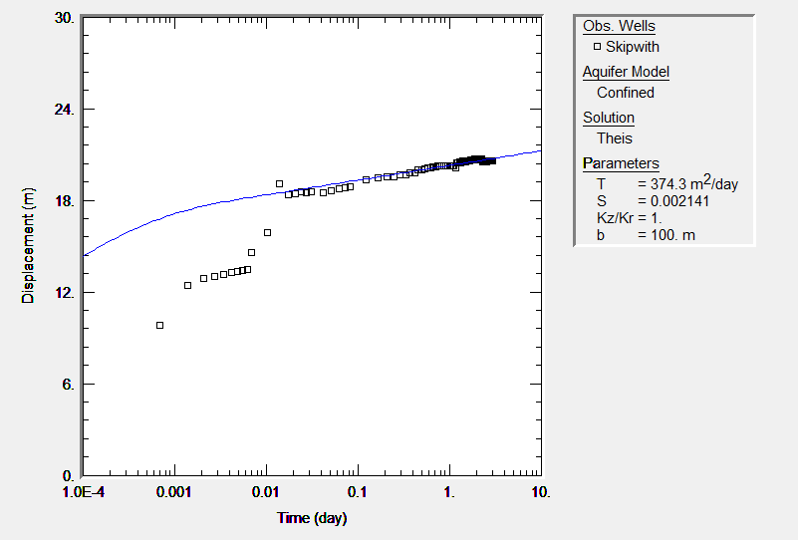

*Figure 3d Skipwith well corrected.*

The storativity and transmissivity values are summarized in Table 2. The storativity obtained from the well modelings do not fit the real situation values as they are very high compared to the actual values (values are usually in the order of 10-4 - 10-6).

*Table 2. Transmissivity and Storativity Values*

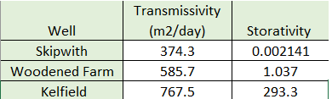

## Numerical Groundwater Flow Model

In order to assess the water balance and preferential flow directions in the Selby aquifer, a steady-state flow model was developed and calibrated using GroundWaterVistas MODFLOW software. Hydraulic conductivity of the Sandstone Aquifer was assumed to be uniform.

The area was discretized into a grid of 100x100 cells followed by importing the Shelby map. To specify the boundary conditions, no-flow boundaries and the river boundaries were defined and the aquifer properties of the hydraulic conductivity (Kx, Ky and Kz) and rainfall recharge for the aquifer zones are fed into the system. A 2D flow model and homogeneous aquifer (Kx = Ky and Kz = 0) was assumed. The values of rainfall recharge were provided. The pumping wells locations in the region were defined in the map along with their pumping rates. The characteristics of 14 head measurements along with the wells that were contaminated are shown (Table.3.). The negative values in the table represent abstraction. Values from observation wells were then imported and are considered as a reference for the model calibration. Results from the initial model run obtained are shown in Figure 4.

The residuals are the differences between target well head values and the model head values. The residuals are negative and colored in red when the model is above the observed levels and positive and colored blue when below.

*Table 3. Production well data for 1992.*

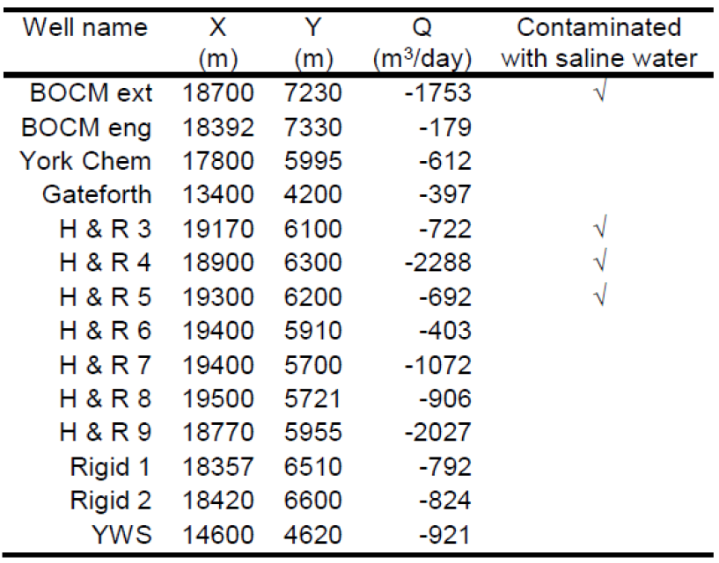

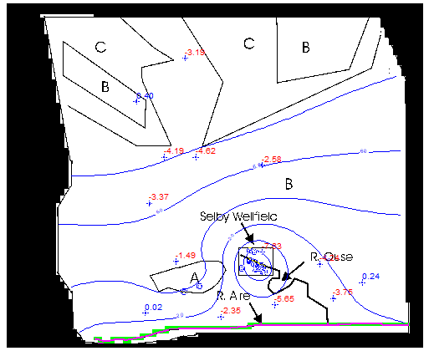

*Figure 4. MODFLOW initial run result.*

## Model Calibration

Sensitivity analysis and evaluation of the variance of the measurement error in the input data is a part of calibration. A manual analysis was performed by changing the values of hydraulic conductivity and the recharge zones 1 and 3 as shown in Table 4; however, this process is time-consuming and complex, so a simplified calibration (autosensitivity analysis function in GWVistas) was also performed by accepting boundary conditions and varying the hydraulic conductivity value and the recharge values for zones 1 (or zone A, the outcropping area at Brayton Barff) and zone 3 (or zone C, the area of sands and gravels in the north), due to lack of sufficient data.

Seasonal variations are not considered as our model is in steady state. In observation boreholes, monthly measurements of heads in the period 1992 to 1996 are tabulated and their averages are shown in the target column (Figure 5). There was not much variation in hydraulic heads during this period. The acceptable error is ± 2 m, so the residual value of below 2 should be satisfactory.

The MODFLOW result for the final run (Figure 6) displays that before calibration, the contoured head lines were less distributed in the area with lower number of contours, but after calibration, they are more dispersed and cover a greater area with a higher number of contours. The head values of the observation wells also changed and were much more close to the ‘0’ mark than in the initial run.

*Table 4. Manual sensitivity analysis results.*

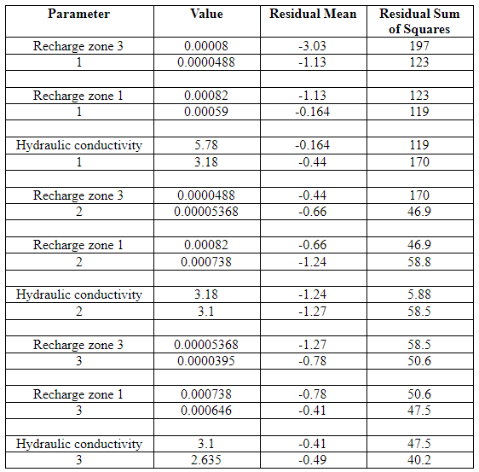

Comparing the original and final values of sum of squared residuals and Root Mean Square (RMS) error, we found that the final result decreased.The residual values for the final result are between ± 2, indicating that the final set of values are closer to the real values. The residual values at each point vary in both the set of values, but in the final set, they are all almost within the acceptable range of ± 2 (Figure 5a & 5b).

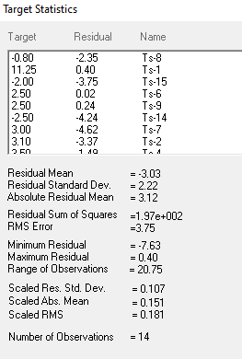

*Figure 5a. Initial Target Statistics obtained in Groundwater Vistas*

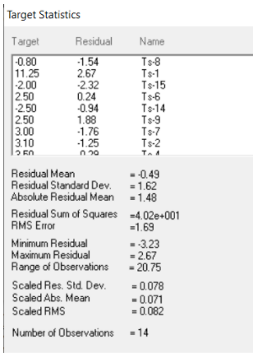

*Figure 5b. Final Target Statistics obtained in Groundwater Vistas*

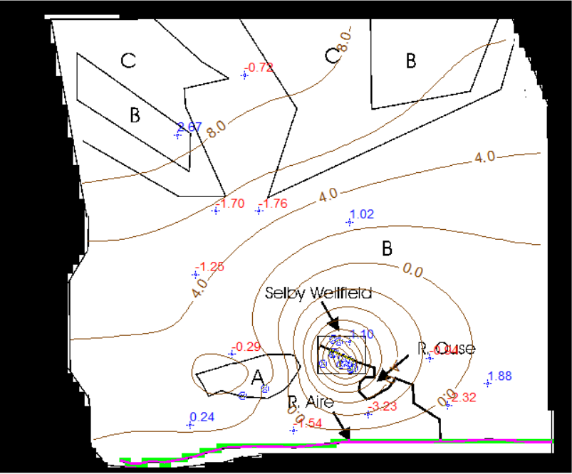 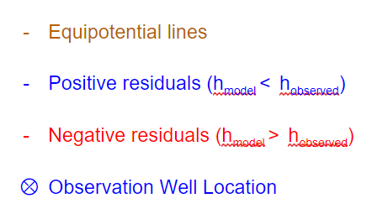

*Figure 6. MODFLOW final results*

The mass balance summary plot shown in Figure 7 shows the well recharge and outflow are balanced. The negative flux represents the withdrawal of water and the positive flux indicates the recharge of the water.

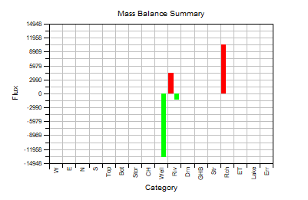

*Figure 7. Mass Balance Summary plot*

## Particle Tracking

Subsequently, particle tracking was performed in order to investigate the possible sources of saline water contamination in the area. Particle tracking is one of the best methods of testing the potential directions and distances for potential contamination. MODPATH was used to determine the flow paths taken by water entering the Selby abstraction wells and to investigate the source of the saline waters. The contaminated wells characteristics are found in Table 3.

The source of the saline waters contaminating wells in the Shelby area are varied based on Selby background. Due to provided geological data of the area, it is a possibility that the intrusion is from the ocean into the Mercia mudstone region into sherwood sandstone. Infiltration of sea-water into the eastern part of the aquifer could have taken place under higher sea-level conditions. Additionally, saline groundwater could possibly have entered from the confined part of the aquifer or from the deep confined part of the aquifer to the east of the modeled area. There may also have been an upward migration of brines from Permian evaporites strata which underlie the Sherwood Sandstone (Figure 1), possibly related to deep coal mining activity and subsidence-related faulting. This migration is a possibility if the aquifer were in hydraulic continuity with groundwaters in the underlying strata, since depression of the groundwater head in the vicinity of the Selby wellfield could induce upwelling of underlying denser brines.

Obtained plots (Figure 8a) reveal that the contaminant source is rooted in the eastern and northern sides of the area. This makes the assumption of saline groundwater entering from the confined part of the aquifer or from the deep confined part of the aquifer to the east of the modeled area a possible source.

Comparing the results of particle tracking of contaminated and uncontaminated zones (Figure 8a & 8b), it can be said that while the intrusion in the contaminated wells is from the north and the eastern side of the area, while for uncontaminated wells, the particle tracking shows that the recharge of the wells stem from the Aire and Ouse Rivers in the south and from the unconfined aquifer A in the west.

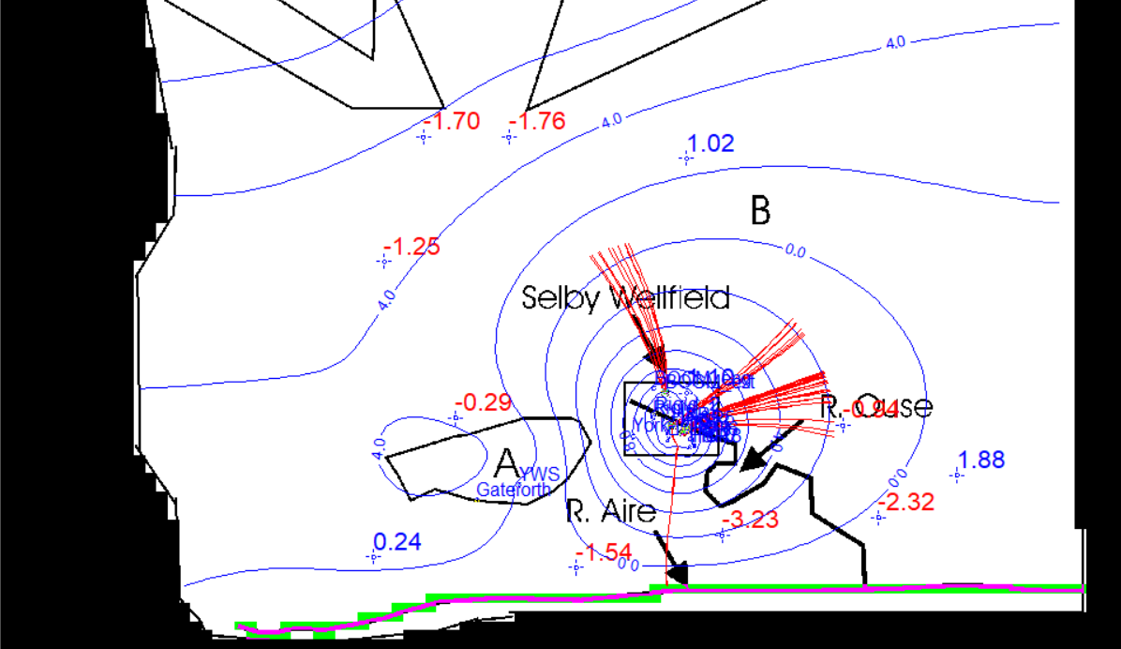

*Figure 8a. PT for all contaminant wells with Porosity= 0.05(wells : BOCM_ext, H & R 3-4-5)*

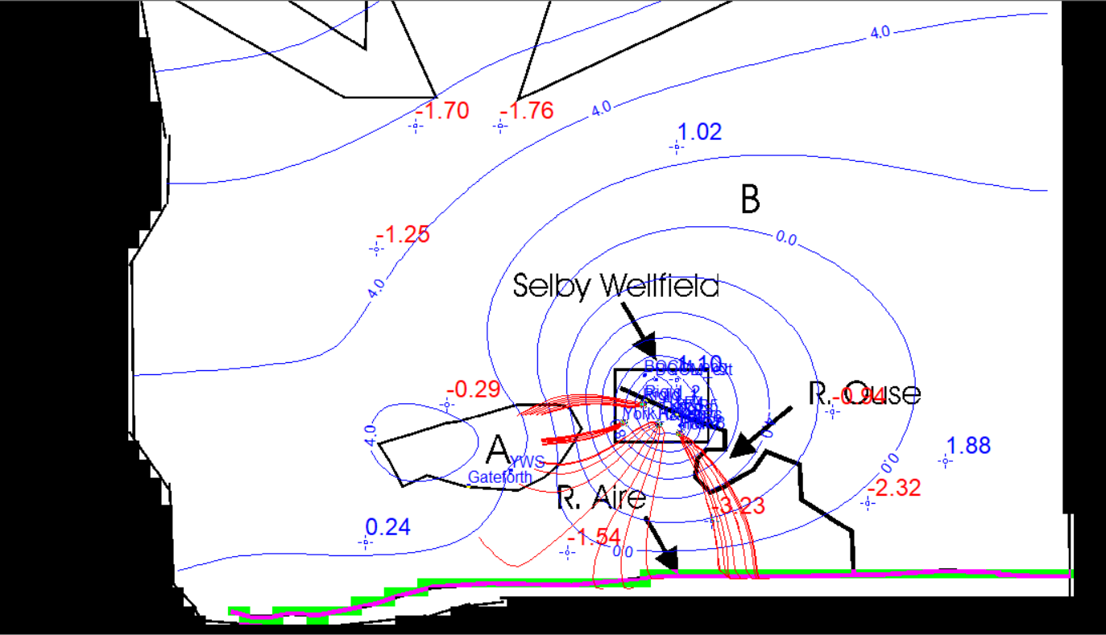

*Figure 8b. PT for all uncontaminant wells with Porosity= 0.05(wells: York Chem, H & R7-9, Rigid 1)*

# Part 2 Transport

## 

## Analysis of transport processes in laboratory column experiments (fixed step injection)

Four columns were sampled from site and a tracer test was performed on them in the laboratory using fixed step conditions, The column has 36 x 5.5 x 1.8 cm (total volume = 356.4 cm3) and the flow rate of water is 2.67 mL/min. A constant concentration Co of a conservative tracer is injected in the column. The C/Co are reported at different distances through the column for 4 different times (148 s, 279 s, 412 s, 550 s).

To estimate parameter values including hydrodynamic coefficient of dispersion (DL) and the dispersivity (α), the Sauty equation is used to perform analytical fitting with experimental data. The results compiled for this experiment are reported in Figure 9 and Table 5:

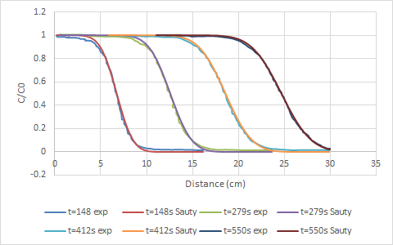

Figure 9. Experimental and calculated results for column tracer test.

Table 5. Experimental and calculated values for column tracer test.

| Time | x(cm) for C/Co=0.5 | Porosity  (%) | Hydrodynamic dispersion coefficient, DL (cm2/s) | Dispersivity (m) |
| --- | --- | --- | --- | --- |
| 148 | 6.7 | 9.885 | 0.006684028 | 0.1469886 |
| 279 | 12.6 | 9.946 | 0.006139687 | 0.1358545 |
| 412 | 18.6 | 9.963 | 0.006341783 | 0.1405669 |
| 550 | 24.6 | 10.024 | 0.005909913 | 0.1317894 |
| Average | | 9.954 | 0.006268853 | 0.1387999 |

Across different times, the results for porosity and dispersion coefficients are reasonable as they fall within typical ranges since they belong to the same sample with some slight deviation due to experimental error. As the dispersivity is in a range of centimeters, it is reasonable for lab scale experiments. The average values of porosity, dispersivity and dispersion coefficient are acceptable.

## 

## Analysis of transport processes in laboratory column experiments (slug injection)

The representative core sections used for this experiment are 50 cm long and induce an effective transport velocity comparable to the field measurement where small flow rate peristaltic pumps were used. Slug injection was performed using different types of tracers: sodium naphthionate, eosine and uranine. Tracer experiments with different concentration and constant flow rate were conducted for eight hours duration to allow as much of the injected tracer mass to be recovered as possible.

*Table 6. Tracer Experiment Parameters.*

| Tracer | Injected concentration [ppb] | Injected volume [ml] | Flow rate [ml/min] |
| --- | --- | --- | --- |
| Uranine | 200 | 80 | 4 |
| Sodium Naphthionate | 200 | 40 | 4 |
| Eosine | 200 | 40 | 4 |

To estimate the hydrodynamic dispersion coefficient and the dispersivity, the experimental data were analyzed with two methods: the analytical solution and the temporal moment analysis method.

## Analytical solution

The Sauty (1980) solution is used to fit the experimental data of each tracer by varying the seepage velocity (u), Hydrodynamic dispersion coefficient (DL) and the porosity in order to minimize the squared error between the experimental data and the analytical solution result using the solver function. The results are illustrated below.

### 1- Sodium-Naphthionate

*Table 7. Experiment results for sodium-naphthionate.*

| U | 0.516 | m/hr |
| --- | --- | --- |
| Hydrodynamic dispersion coefficient, DL | 0.0257 | m2/hr |
| Dispersivity | 0.0498 | m |
| Porosity | 5.9 | % |

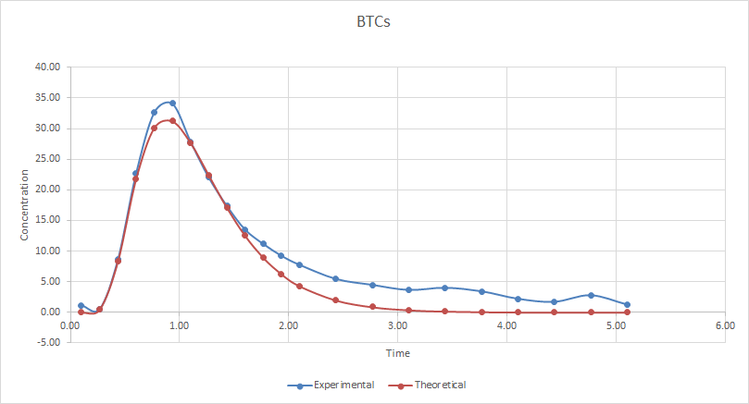

*Figure 10. BTC curve for experimental and theoretical sodium-naphthionate tracer.*

### 2- Eosine

*Table 8. Experiment results for eosine tracer.*

| u | 0.2963 | m/hr |
| --- | --- | --- |
| Hydrodynamic dispersion coefficient, DL | 0.0718 | m2/hr |
| Dispersivity | 0.242 | m |
| Porosity | 10.32 | % |

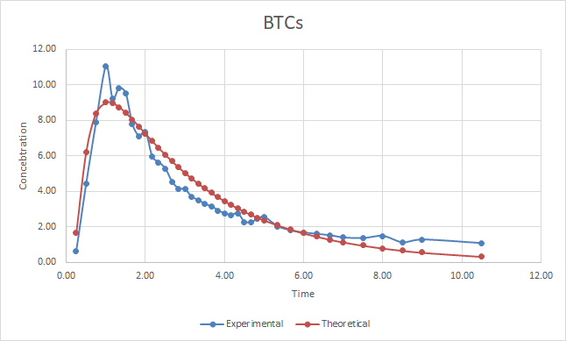

*Figure 11. BTC curve for experimental and theoretical eosine tracer.*

### 3- Uranine

*Table 9. Experiment results for uranine tracer.*

| u | 0.3008 | m/hr |
| --- | --- | --- |
| Hydrodynamic dispersion coefficient, DL | 0.0206 | m2/hr |
| Dispersivity | 0.0685 | m |
| Porosity | 10.17 | % |

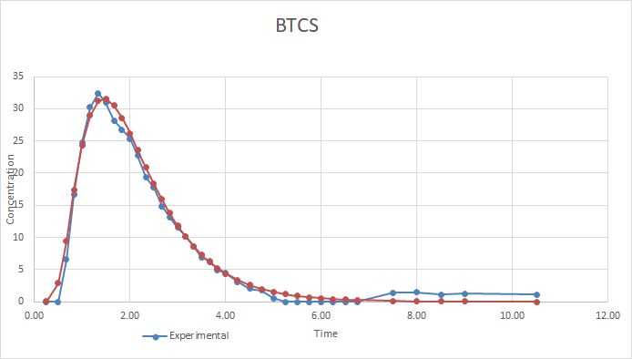

*Figure 12. BTC curve for experimental and theoretical uranine tracer.*

Comparing the two types of analytical solutions, the fixed step method and the slug injection method, in fixed step conditions the concentrations have been measured at different distances with constant time (Gaussian) curve, whereas with the slug injection the concentration is measured at the end of column through different time steps (BTC). While the concept of the two solutions is different, both result in similar range values for dispersivity with the fixed step solution range equal to 13.5 cm and the slug injection giving a wide range of variation between 6-24 cm. However, the value of the hydrodynamic dispersion coefficient varied with one order of magnitude. This may be due to the velocity variation.

As for porosity, the two solutions provided similar values of almost 10% except for sodium-naphthionate which resulted in a value of 5.6% due to the experimental data error in measurement shown on the BTC graph.

## Temporal Moment Analysis Method

Using the temporal moment analysis, the zero, first and second order temporal moments were used to estimate the hydrodynamic dispersion coefficient, porosity and the dispersivity.

The zero order temporal moment is related to the amount of mass recovered at the end of the experiment (area under the curve), while the first and second order normalized temporal moments are functions of the advective velocity u, and the longitudinal dispersion DL (or the Peclet number).

*Table 10. Moment analysis parameters estimation.*

|  |  |  | Peclet | Assuming high Peclet number | | Peclet |
| --- | --- | --- | --- | --- | --- | --- |
| Uranine | U (m/hr) | 0.2956 | 9.7 | U (m/hr) | 0.2453 | 10.0 |
| DL (m2/hr) | 0.0152 | DL (m2/hr) | 0.0122 |
| Porosity (%) | 10.34 | Porosity | 12.47 |
| Na-Nathtionate | U (m/hr) | 0.4537 | 4.3 | U (m/hr) | 0.3097 | 4.8 |
| DL (m2/hr) | 0.0527 | DL (m2/hr) | 0.0324 |
| Porosity (%) | 6.74 | porosity | 9.87 |
| Eosine | U (m/hr) | 0.3142 | 5.9 | U (m/hr) | 0.2350 | 6.3 |
| DL (m2/hr) | 0.0265 | DL (m2/hr) | 0.0185 |
| Porosity (%) | 9.73 | Porosity(%) | 13.01 |

The assumption of high Peclet number is not valid because the Peclet number is lower than 20 for the three tracers. This was obvious when calculating the Peclet number; however, this method is kept for illustrative purposes.

The porosity values obtained in the temporal moment analysis are in line with the analytical solution having almost the same values and also a lower value for sodium-naphthionate due to the experimental error. Comparing temporal moments with analytical solutions, it can be seen that the range of hydrodynamic dispersion coefficients is similar to the ones obtained from the slug injection solution.

## Chemical reactions typical in groundwater: sorption in natural soils

During the drilling of the Kelfield, Skipwith and Woodend Farm wells at the “Selby” site (UK), surface soil samples were collected. The soil samples were air dried and passed through 2-mm sieves for analysis, then soil properties such as soil pH, cation exchange capacity (CEC), and particle size analysis were determined in standard laboratory analysis. During the drilling of the Kelfield, Skipwith and Woodend Farm wells at the “Selby” site (UK), surface soils samples were collected, soil samples were air dried and passed through 2-mm sieves for analysis, then soil properties such as soil pH, cation exchange capacity (CEC), and particle size analysis were determined in standard laboratory analysis. To investigate Ni and Cd adsorption for the selected soils, the batch equilibration technique was used.

### 

*Table 11. Laboratory soil analysis for three locations.*

| Soil | Kelfield | Skipwith | Woodend Farm |
| --- | --- | --- | --- |
| pH | 5.80 | 6.11 | 6.92 |
| TOC (%) | 0.83 | 2.03 | 4.02 |
| CEC (cmol/kg) | 8.60 | 2.00 | 27.00 |
| Sand (%) | 5.00 | 77.00 | 39.00 |
| Silt (%) | 89.00 | 20.00 | 39.00 |
| Clay (%) | 6.00 | 3.00 | 22.00 |

The above results combined with soil texture as below graph were used to classify the soil.

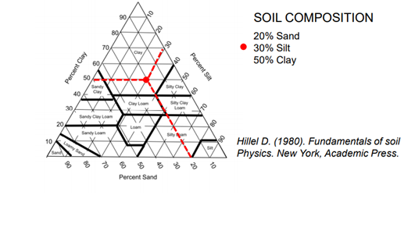

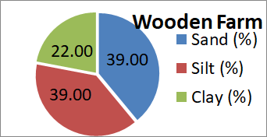

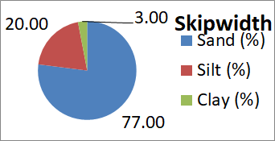

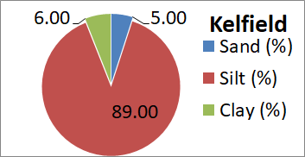



## Sorption Mechanisms

In order to characterize the sorption behavior of selected heavy metals (Nickel and Cadmium) in a single component system we used equilibrium isotherm models that resulted in the following sorption parameters. Given the experimental values the parameters of the Freundlich and Langmuir models were estimated, tabulated and plotted below.

### 1- Freundlich Model

*Table 12. Parameter values for Nickel Freundlich model.*

| Nickel | Skipwith | Kelfield | Woodend Farm |
| --- | --- | --- | --- |
| Loamy Sand | Silt | Loam |
| n | 0.5711 | 0.6038 | 0.6173 |
| Kf | 2.826 | 14.709 | 48.073 |

*Table 13. Parameter values for Cadmium Freundlich model.*

| Cadmium | Skipwith | Kelfield | Woodend Farm |
| --- | --- | --- | --- |
| Loamy Sand | Silt | Loam |
| n | 0.699 | 0.6309 | 0.6205 |
| Kf | 6.012 | 24.18 | 26.730 |

### 2- Langmuir Model

*Table 14. Parameter values for Nickel Langmuir model.*

| Nickel | Skipwith | Kelfield | Woodend Farm |
| --- | --- | --- | --- |
| Loamy Sand | Silt | Loam |
| qmax | 1.921 | 5.459 | 6.9153 |
| Kl | 10.443 | 28.596 | 126.04 |

*Table 15. Parameter values for Cadmium Langmuir model.*

| Cadmium | Skipwith | Kelfield | Wooden Farm |
| --- | --- | --- | --- |
| Loamy Sand | Silt | Loam |
| qmax | 4.266 | 6.956 | 6.977 |
| Kl | 5.481 | 35.595 | 45.951 |

Through running an isotherm analysis, one can see cadmium follows closely with the Freundlich model whereas nickel and cadmium do not fit well to the Langmuir model.

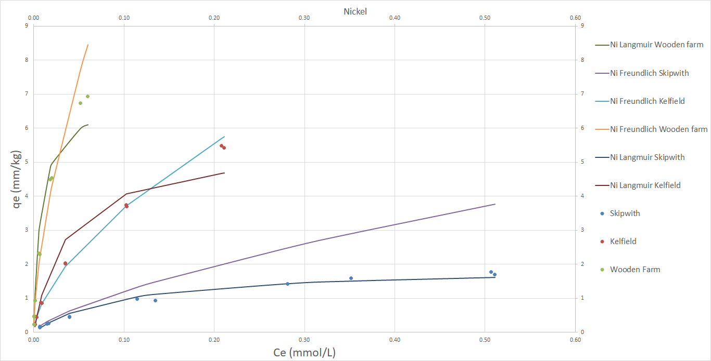

*Figure 13. Freundlich and Langmuir isotherms for nickel sorption at three locations.*

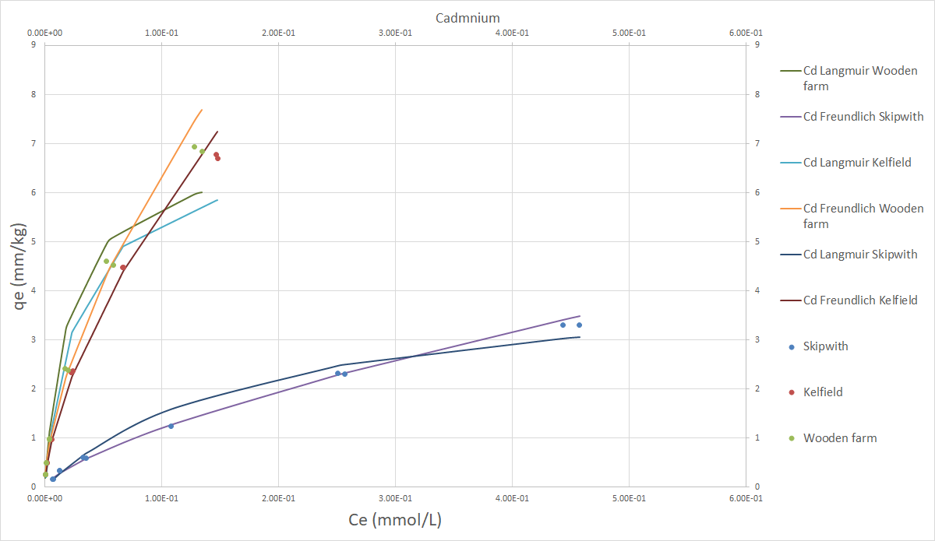

*Figure 14. Freundlich and Langmuir isotherms for cadmium sorption at three locations.*

*Table 16. Summary of affinity sequences.*

| Soil | Kelfield | Skipwith | Woodend Farm |
| --- | --- | --- | --- |
| Affinity Sequence | Cd > Ni | Cd > Ni | Ni > Cd |

In general, the major factor on soil sorption is cation exchange capacity (CEC), which is linked to clay content in the soil, since clay is considered a source of negative charge in soil that attracts the minerals (cations) to its surface. Therefore high clay content will result in high sorption (soil affinity). Therefore, since Kelfield and Skipwith have a higher clay content, they have a higher affinity for sorption of cadmium compared to nickel while the opposite is true for Woodend Farm.

# Part 3 Geostatistics

Many uncertainties are present in modeling the Selby aquifer due to the inability to deterministically measure and interpret groundwater conditions; therefore, it is necessary to use a geostatistics approach to improve the model by incorporating the uncertainties associated with the hydraulic conductivity in the field.

## Variogram Models’ Estimation:

The first step in including these uncertainties is characterizing the dependency of variables on other variables of the same type at different points. This can be accomplished using an experimental variogram which measures the correlation between sets of observation pairs located at some lag distance from each other. SGeMS software was used to create an experimental variogram model of Y = ln K, and then fit these data to the spherical, exponential, and Gaussian models. Because it was a 2D model, it was necessary to consider 5 parameters: distance, tolerance, azimuth direction, azimuth tolerance and bandwidth. We considered an omnidirectional system for this analysis and tested multiple lag separations and tolerances to determine the optimal values for this model. The optimal lag separation was 3500 for this model. Each model (exponential, spherical, and Gaussian) with range and sill were then fit to the exponential model with the range corresponding to 95% of the maximum variogram (Figure 1). The sum of squared residuals was tabulated (Table 1).

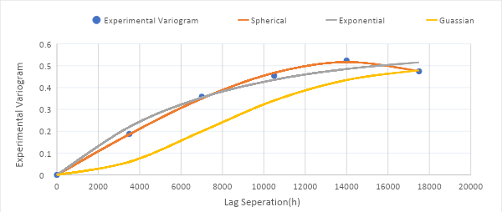

*Figure 15. Experimental variograms with spherical, exponential and gaussian models.*

## Kriging Interpolation Method

The Kriging interpolation method was performed in order to solve for ln K at locations where data is not available. The interpolation is based on the variogram model selected. The interpolation was performed over a grid of 100 x 100 elements (with dimension size 315 m x 260 m). The spherical variogram was found to have the least sum of squared residuals with a corresponding sill of 0.51 and range of 14297.4m (Table 1).

*Table 17. Models' Parameter and Performances.*

|  | **Spherical** | **Exponential** | **Gaussian** |
| --- | --- | --- | --- |
| **Variance (Sill)** | 0.51 | 0.56 | 0.5 |
| **Range(a) (m)** | 14297.4 | 21159.9 | 17000 |
| **SSR** | 0.00029 | 0.004575 | 0.062291 |

The Kriging estimation was performed for all elements on a cartesian grid according to the model’s parameters. Four values of the search ellipsoid (10000, 15000, 20000, 30000) were tested to determine the maximum neighborhood to be evaluated. A search ellipsoid was used to reduce errors due to larger values of lag separation when the second order stationarity assumption does not hold. The distribution of measurement points is densest in the lower right corner of the model (Figure 2).

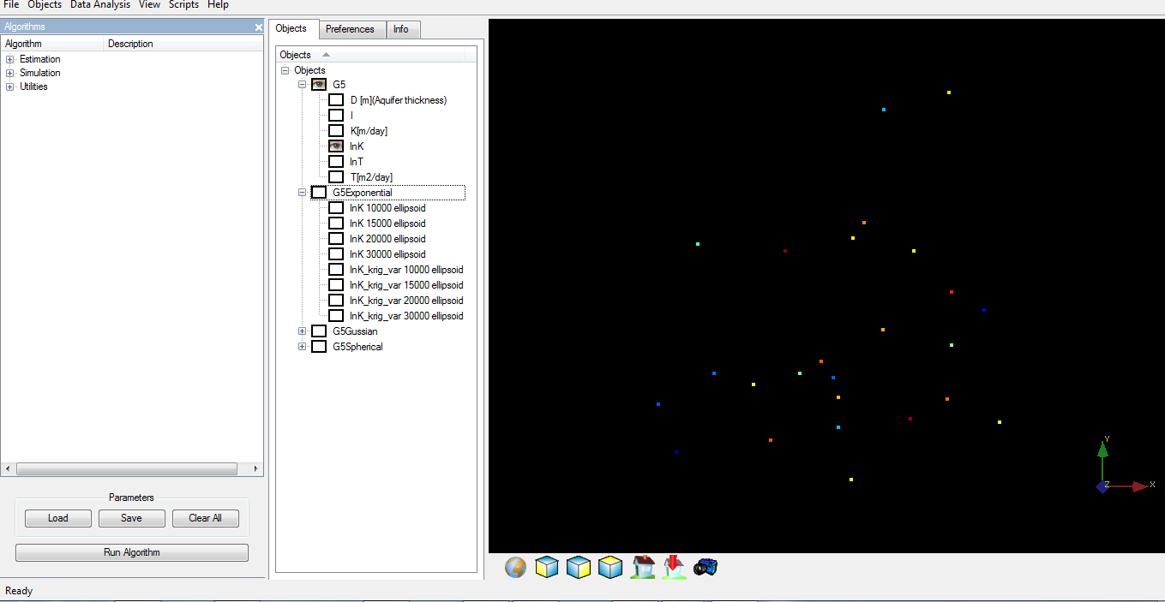

*Figure 16. Measured ln K points of Selby in SGeMS.*

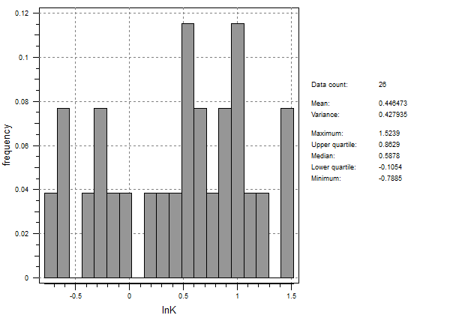

*Figure 17. Statistics of measurement points,*

From a practical point of view, the nugget value of the model was assumed to be 0.002 for the Kriging estimation. This nugget value prevents Gaussian models from accumulating numerical errors because it has a strong correlation with small lags. In generating the new kriging field, the distribution contours of ln K were obtained for each model and ellipsoid.

The kriging estimate colormaps for the four ellipsoids tests for the exponential model based on is shown in Figure 3:

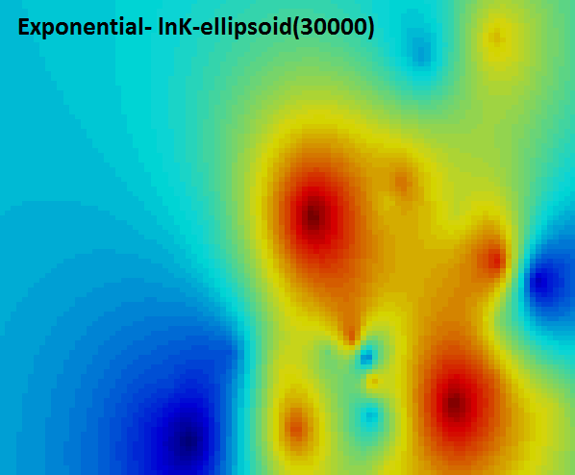 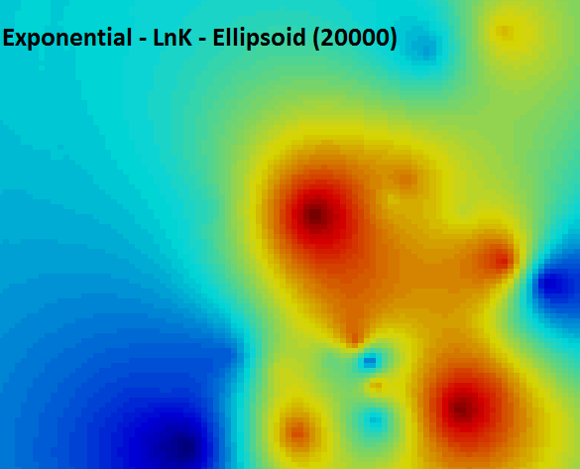 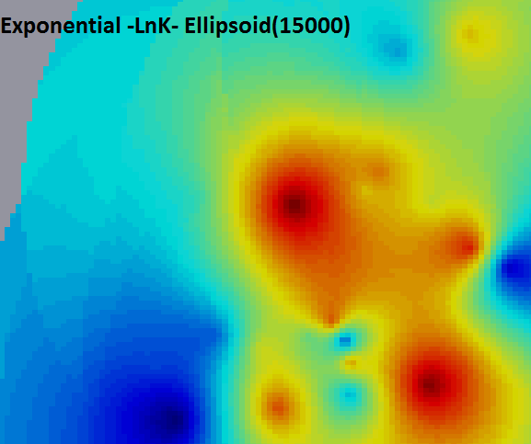 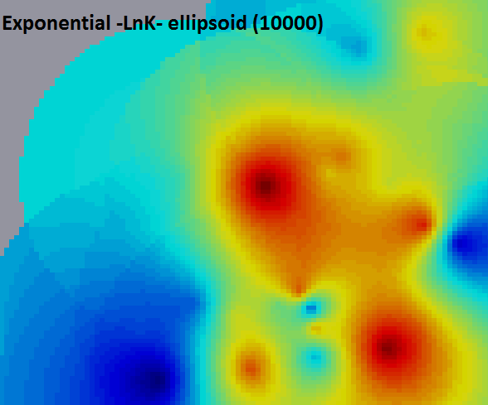 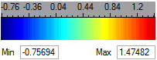

*Figure 18. Kriging colormaps for four ellipsoids for exponential model (30000, 20000, 15000, 10000).*

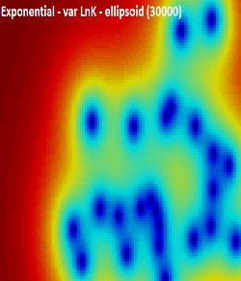 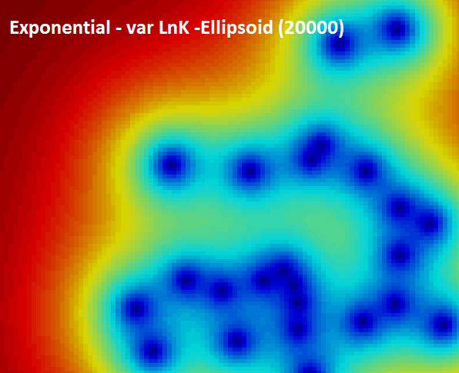 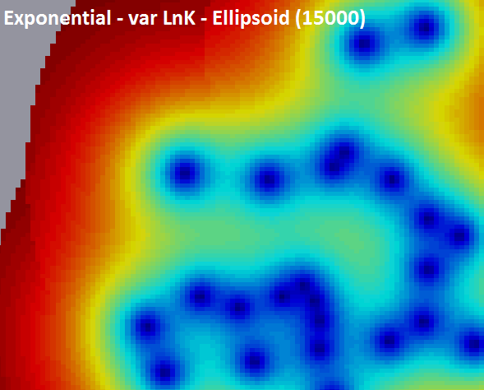 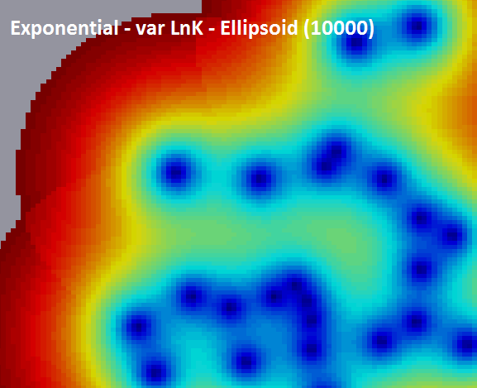 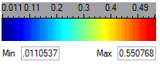

*Figure 19. Variance estimation for exponential model for ellipsoids (30000, 20000, 15000, 10000).*

As it is shown in the colormaps in Figure 3, by decreasing ellipsoid, the domain decreases and in the upper left part of the aquifer there is a lack of measurement data used in the kriging estimate. The larger the ellipsoid, the smoother the estimated area and the less localized the estimation. The kriging field behaves like a circular shape which shows that the heterogeneity of the aquifer has been spread in a circular distribution and there is no preferential heterogeneity for the x or y direction. The variance of the estimation distribution is lower in the lower right part and higher in the upper left part of the field due to the concentration of measurements in the lower right corner. There are no significant differences in variance between the size of the ellipsoids.

The mean and variance histograms for ellipsoid size 20000 are shown in Figures 5 and 6.

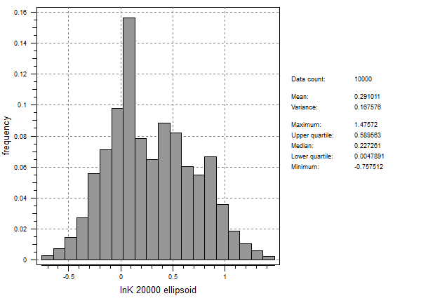

*Figure 20. Mean estimation (kriged) Statistics using exponential model.*

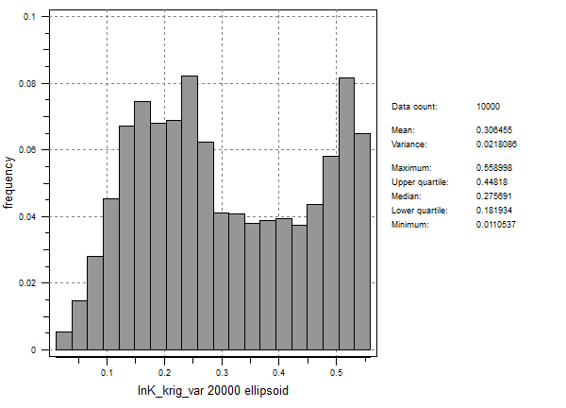

*Figure 21. Variance of points using exponential model.*

The analysis was performed on the spherical and Gaussian models as well which exhibited similar characteristics to the exponential model. The kriging contours for the spherical model and corresponding variance are shown in Figures 7 and 8.



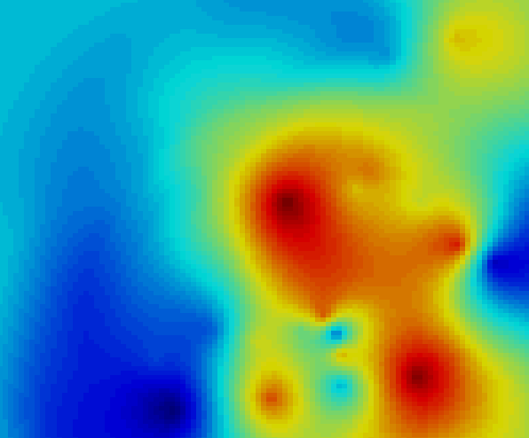

*Figure 22. Kriging colormaps for spherical model for ellipsoid (20000).*



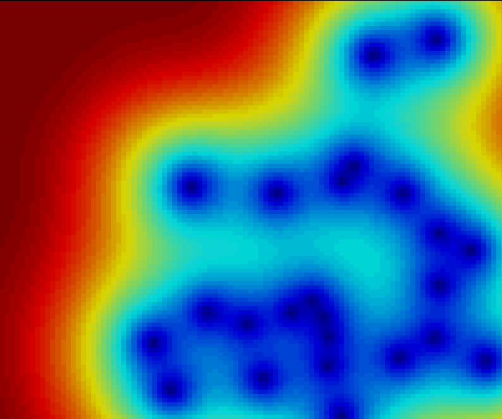

*Figure 23. Variance contour for spherical model for ellipsoid (20000).*

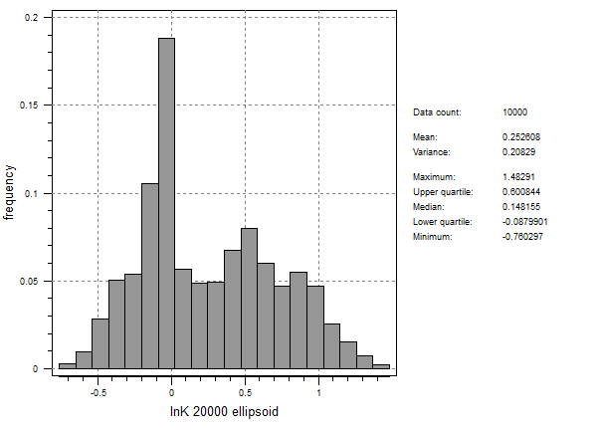 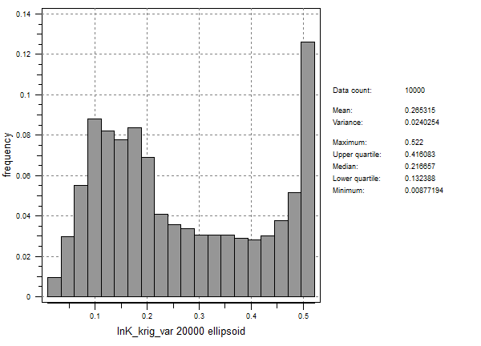

*Figure 24. Mean and variance histograms using the spherical model.*

The kriging colormaps for the Gaussian model and corresponding variance are shown in Figures 10 and 11.

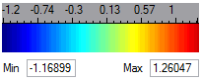

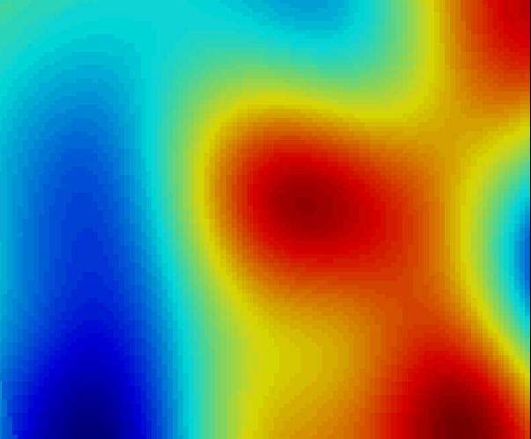

*Figure 25. Kriging colormaps for Gaussian model for ellipsoid (30000).*

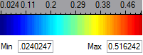

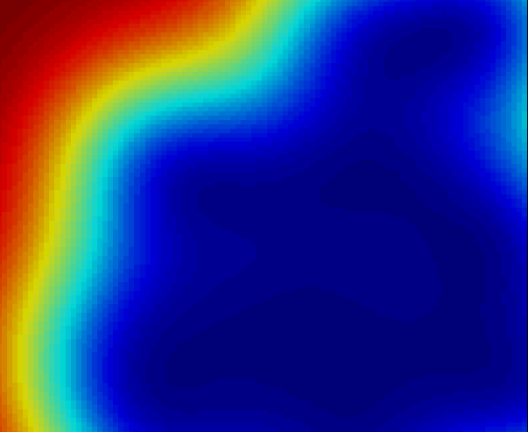

*Figure 26. Variance contour for Gaussian model for ellipsoid (30000).*

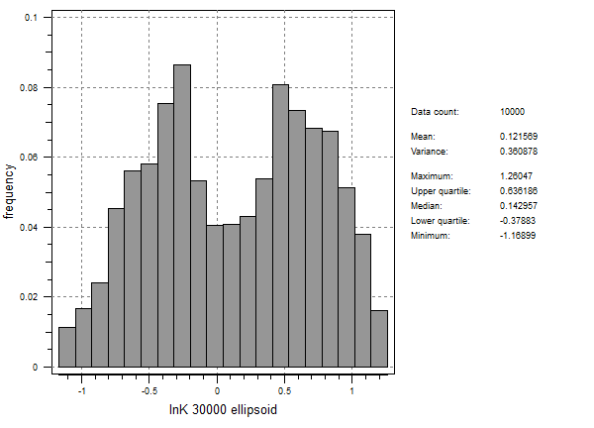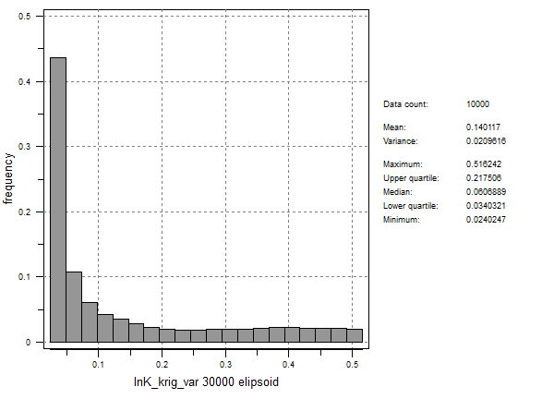

*Figure 27. Mean and variance histograms using the Gaussian model.*

## Sequential Gaussian Simulation

The probabilistic well capture zone defines the likelihood of a particle being captured by the well when located at a specific point. Determining these values requires multiple heterogenous realizations of the hydraulic conductivity field and evaluating the probability of occurrence in a specific row and column across the 10 realizations. The BOCM_ext well was used for this project.

Performing this analysis required several steps. First 10 realizations of ln K were created in SGeMS. Next, these realizations were run through GroundWater Vistas MODFLOW and MODPATH. Using MODPATH, we performed a reverse particle tracking analysis to delineate the probabilistic well capture zone area. The data obtained from each successive realization in MODPATH was then evaluated row by row in the 2D space. Each row had a frequency of occurrence associated with the center of each cell. By summing the ten realizations’ frequencies for a single row, we could obtain the following plots (shown for row 39 and 43) (Figures 13 and 14).

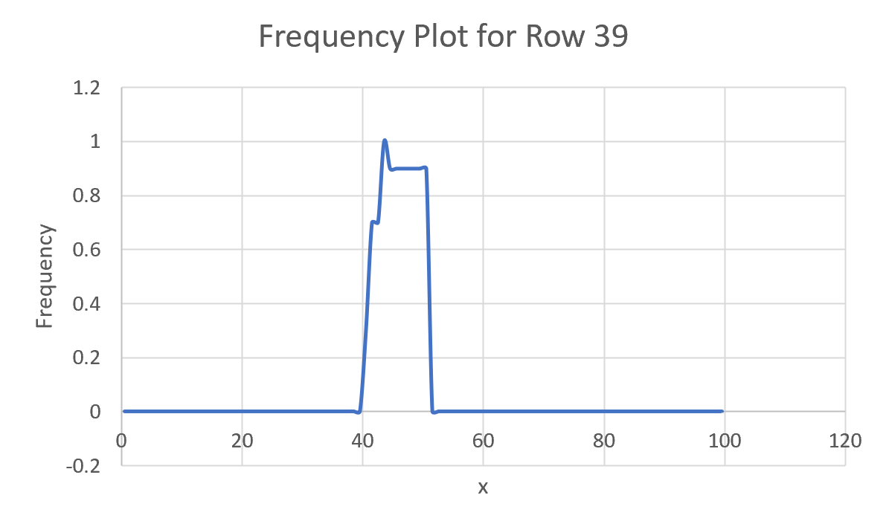

*Figure 28. Particle frequencies for row 39.*

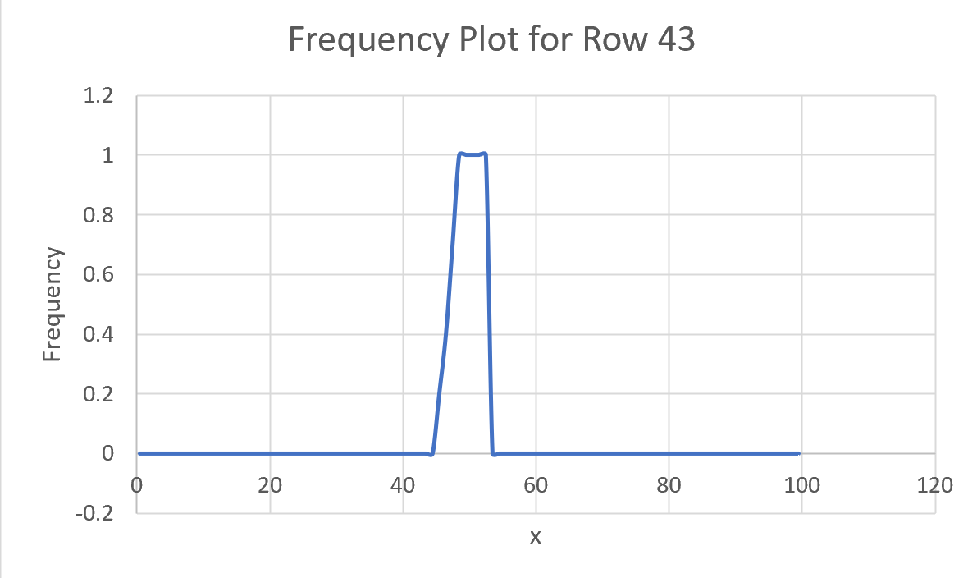

*Figure 29. Particle frequencies for row 43.*

As one can see, the greatest frequency of particles occurs in the center of the graph, with both of these rows corresponding to areas above the BOCM_EXT well as in Figure 15.

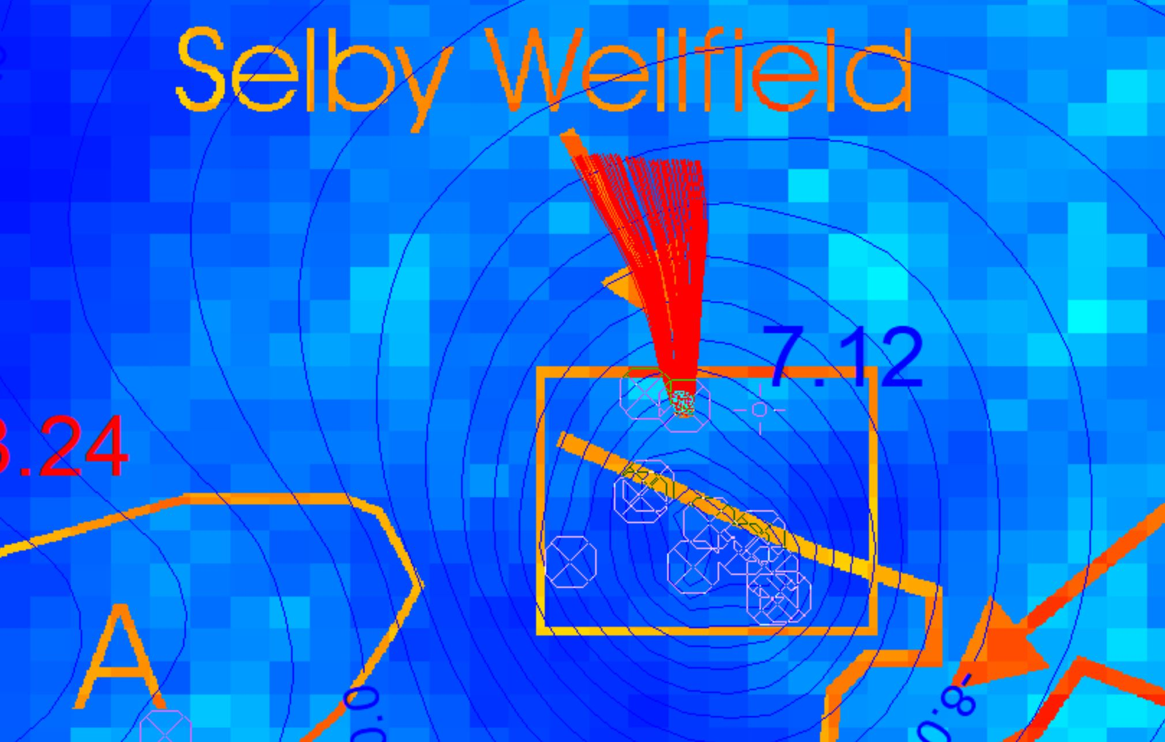

*Figure 30. Particle tracking from BOCM_EXT well.*

The plume extension is based on the travel time considered and the porosity set. For the project, we selected a porosity value of 0.2; however, by decreasing the porosity value for a set time, the plume would extend further because it is easier for the particles to travel through the soil matrix. Thus, a more conservative design could assume a lower porosity value if contamination of the well is a concern.

Finally, a graph of all the probability distributions across all the rows with particles is shown in Figure 16.

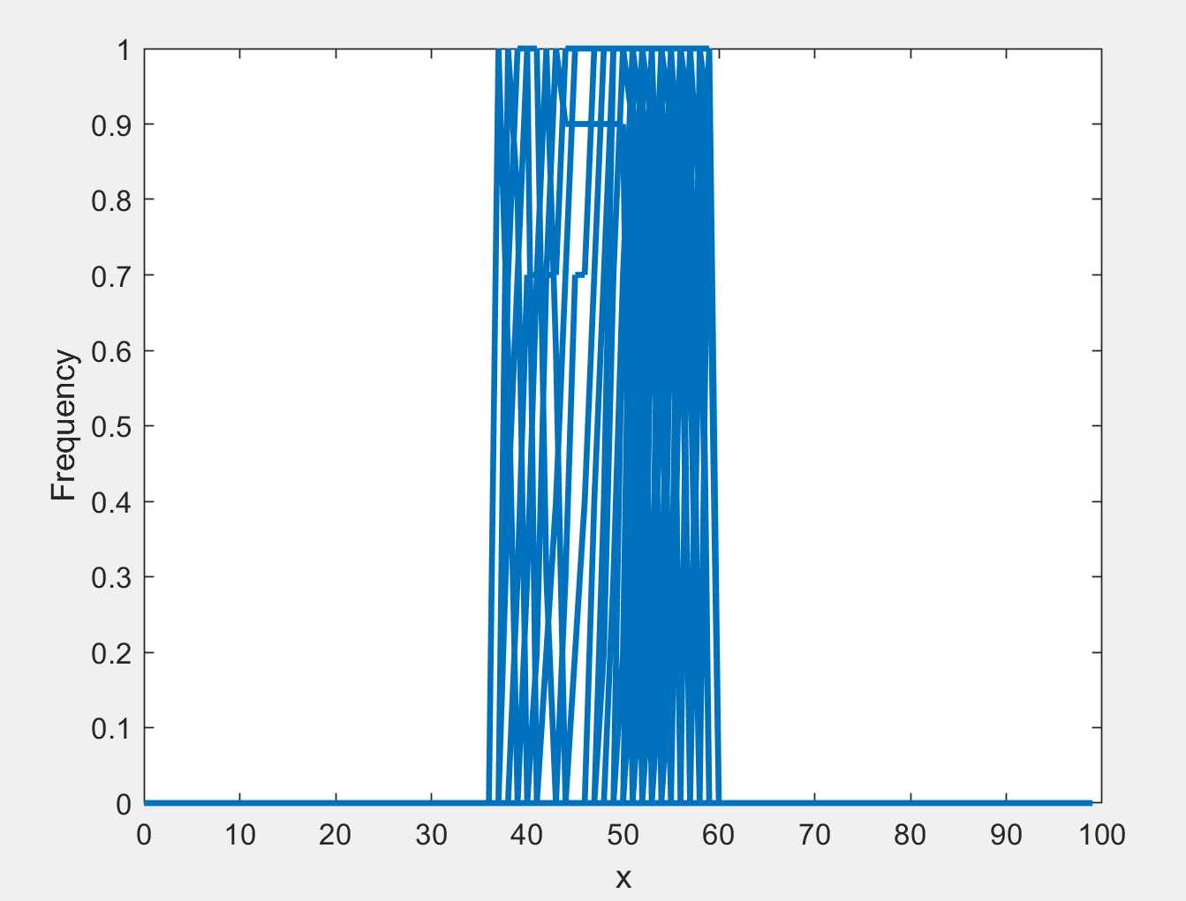

*Figure 31. Particle frequencies for all rows across the x direction.*